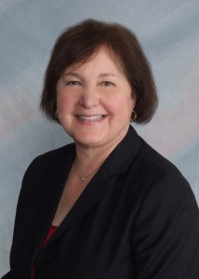
Brief Biography: Susan Kabot, EdD, CCC-SLP
Susan Kabot is the Executive Director of the Autism Institute at the Mailman Segal Center for Human Development at Nova Southeastern University, where she has developed and administered programs for children and young adults for over 33 years. She is Affiliated Faculty for the Fischler College of Education and the Farquahar Undergraduate Honors College, where she teaches courses in autism and developmental disabilities at the undergraduate, masters, and doctoral levels. She also serves as a dissertation chair and member for the Fischler College.
Susan has received a number of NSU President’s Faculty Research and Development Grants and Quality of Life grants, serving as Principal Investigator, Co-Investigator, and Collaborator. She has worked with other departments across NSU and other universities to support research using the Baudhuin Preschool population. She serves as a Consumer Reviewer for the Department of Defense’s Autism Research Program.
Susan is the current Chair of the Florida Developmental Disabilities Council, completing her eighth year, advocating for individuals with developmental disabilities, supporting projects that research information needed to support public policy, create model programs for dissemination throughout the state, and develop self-advocates and family members to be effective voices for systems change.
She also provides technical assistance and professional development to school districts in Tennessee and camps providing specialized services to children with autism.

