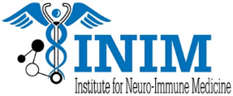
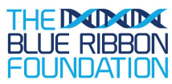
2018 The Blue Ribbon Fellowship Application

Instructions: Please complete this application in full and submit to Ana Del Alamo, Administrative Director of the INIM at adelalamo@nova.edu, no later than June 1, 2018 at 5 P.M. Hand written applications and incomplete applications will not be accepted.
Applicants will be notified by June 8, 2018 of their acceptance.
- Full Name:

- Are you in good academic standing?

- Provide a brief personal statement and explain how you feel this program will help you in achieving your professional goals:

- Name of your Faculty Mentor__________________________________

- Signature of your Faculty Mentor__________________________________

- Please submit the following documents along with this application:
  - Full Research Proposal:
    - Title
    - Summary
    - Research Strategy
    - Significance
    - Innovation and Impact
    - Approach
    - References
  - Updated CV

