Access Zoom
Login to your Zoom account from a classroom computer so that you can access your scheduled Zoom meetings.
- Navigate to https://zoom.nova.edu.
- Click sign in.
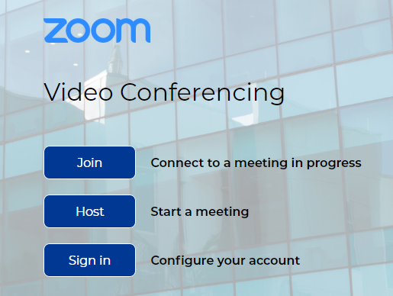

- Enter your NSU email address.
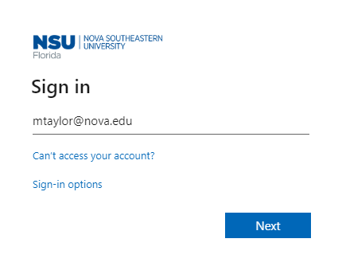

- You will be redirected to an NSU login page.

- Sign in with your NSU email address and password.
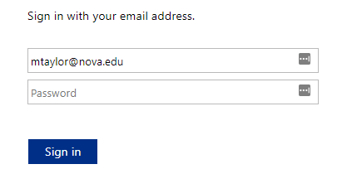

  - You may receive a 2-factor authentication verification request. If so, enter the code that was texted to your mobile device and click verify.
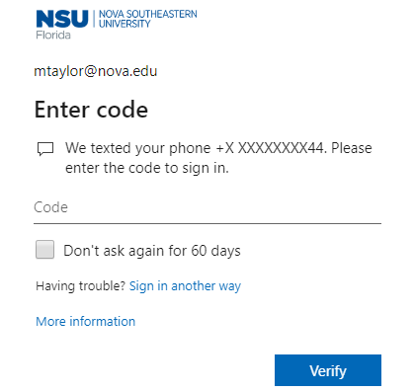

- You will be redirected to your Zoom profile page.
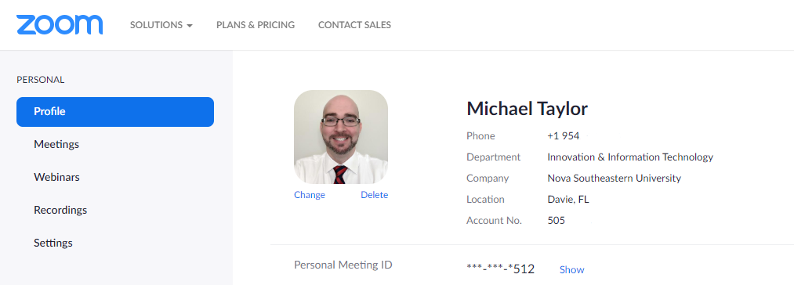

Start a Zoom Meeting
After successfully logging into your Zoom account, you can use the Zoom webpage to launch your Zoom meetings.
- Click Meetings on the left.
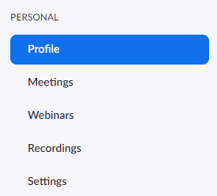

- Find the meeting you would like to initiate and click Start to begin.

- Click Open Zoom when the window appears that says, “Open Zoom? https://nova.zoom.us wants to open this application.”

- Select Join with Computer Audio when the Zoom application prompts you to select how you would like to connect to the audio portion of the meeting.
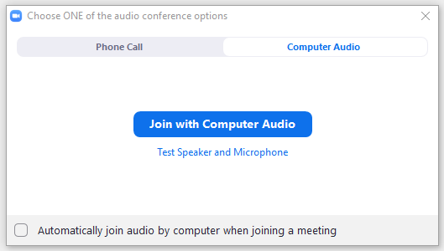
- After joining the audio portion of the meeting, the Zoom application will open.
- You will have the following options available:
c.
j.
i.
h.
g.
f.
e.
a.
b.
d.
  - Mute/Unmute your mic.
  - Start/Stop your video.
  - Security includes: 1. Lock meeting. 2. Enable waiting room. 3. Allow participants to screen share, rename themselves, and chat.
  - Show/hide the participants panel.
  - Show/hide the chat.
  - Share Screen includes: 1. Whiteboard 2. Desktop 3. Specific applications 4. iPhone or iPad. 5. Content from a second camera (in advanced).
  - Turn on recording.
  - Display reactions (thumbs up, clap, etc…).
  - More includes: 1. Closed captions. 2. Breakout rooms.
  - End your meeting.

- At the end of your meeting, open Zoom, click your profile picture in the top right-hand corner of the application and click sign out.
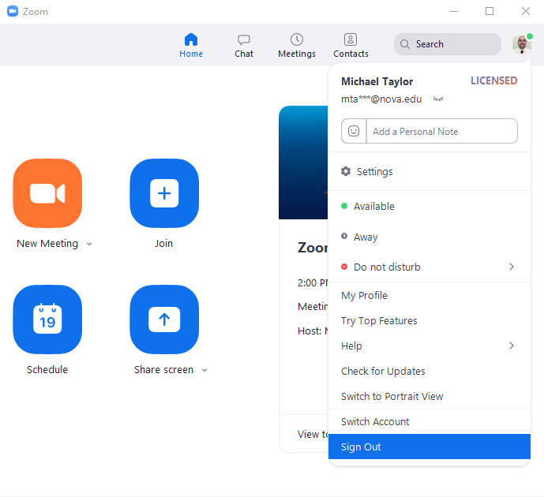

- You will also want to make sure you sign out of Zoom in the internet browser you used to login. Click your picture in the top right-hand corner of the browser and click sign out.
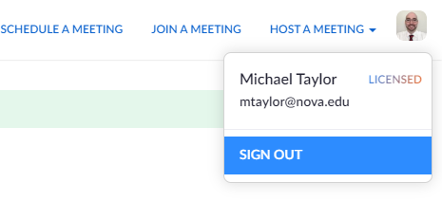

Switching Between Two Cameras During a Meeting
If you have more than one web camera connected to your computer, you can actively switch back and forth between cameras during a Zoom session.
- Click the up arrow to the right of the Start/Stop Video button on your Zoom control panel.
- Click the name of a camera on screen to actively switch
or
Use the keyboard combination of Alt + N to switch on the fly.
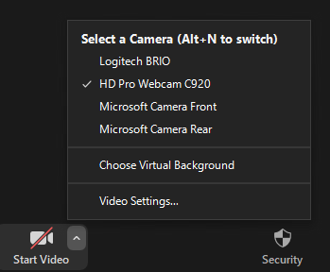

Publishing your Zoom Recording to SharkMedia
After your recording has been completed a copy of it will be available in SharkMedia later that day. From the My Media in SharkMedia, you can make your Zoom recording available to your target audience by unlisting the recording or publishing to a channel(s) you have access to.
- Login to https://sharkmedia.nova.edu.
- Click your name in the upper right corner and select My Media.
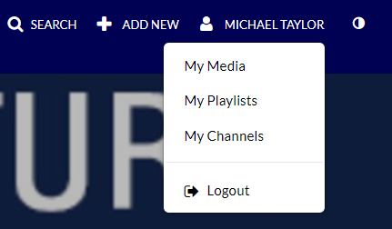

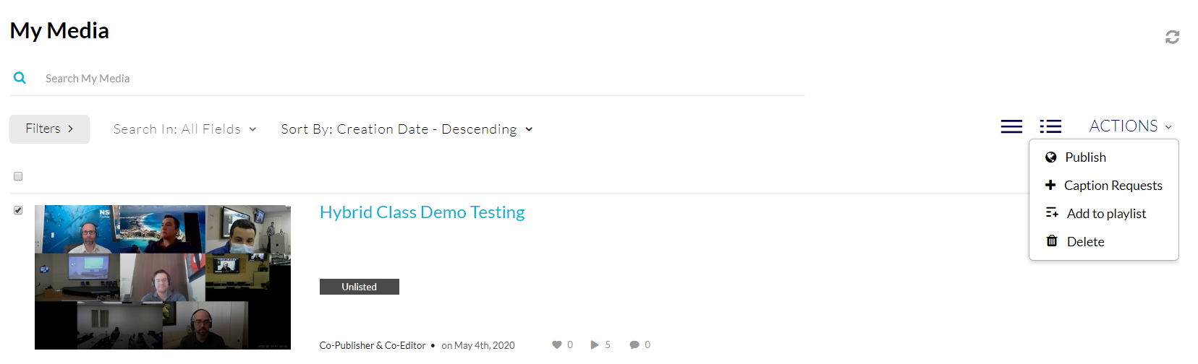
- Click the checkbox next to the recording you want to add to make available to others, click Actions in the top right corner and select Publish.

- Select your publishing option.
  - Private – only visible to you.
  - Unlisted – Visible to anyone with the link to the recording.
  - Published – Visible to anyone with permissions to access the channel.
