Access Zoom
Login to your Zoom account from a classroom computer so that you can access your scheduled Zoom meetings.
- Navigate to https://nsu.instructure.com.
- Enter your NSU username and password, then click LOG IN.
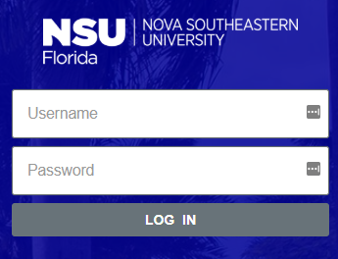

- You will be redirected to Canvas dashboard landing page.
- Click on a course where you have Zoom meetings scheduled in order to access it.
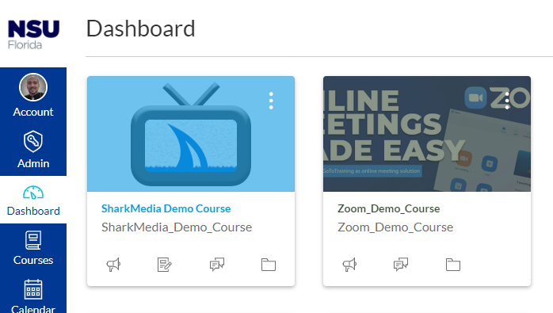

- In your course menu you should have already added the Zoom menu item. Click on it to access the Zoom-Canvas integration.
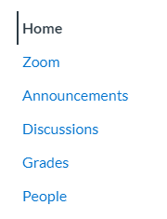

- You should see your Zoom Upcoming Meetings listed by default.
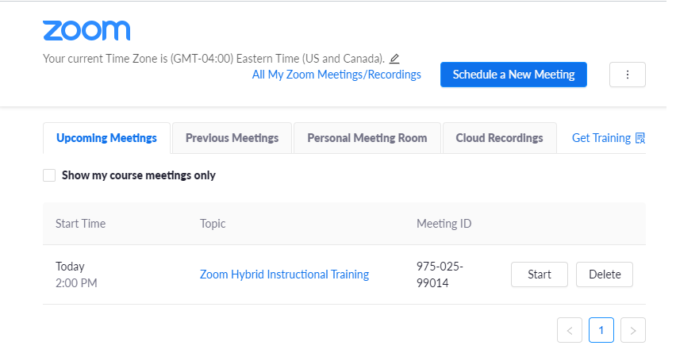

- Click the Start button next to the meeting you would like to begin.

- Click Open Zoom when the window appears that says, “Open Zoom? https://nova.zoom.us wants to open this application.”

- Select Join with Computer Audio when the Zoom application prompts you to select how you would like to connect to the audio portion of the meeting.
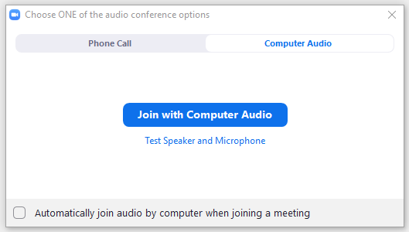

- After joining the audio portion of the meeting, the Zoom application will open.
- You will have the following options available:
c.
j.
i.
h.
g.
f.
e.
a.
b.
d.
  - Mute/Unmute your mic.
  - Start/Stop your video.
  - Security includes: 1. Lock meeting. 2. Enable waiting room. 3. Allow participants to screen share, rename themselves, and chat.
  - Show/hide the participants panel.
  - Show/hide the chat.
  - Share Screen includes: 1. Whiteboard 2. Desktop 3. Specific applications 4. iPhone or iPad. 5. Content from a second camera (in advanced).
  - Turn on recording.
  - Display reactions (thumbs up, clap, etc…).
  - More includes: 1. Closed captions. 2. Breakout rooms.
  - End your meeting.

- At the end of your meeting, the Zoom application should display the Join a Meeting and Sign In options on screen to validate you are not logged into Zoom anymore.
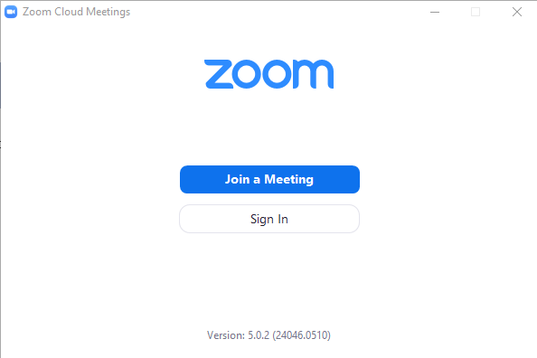

- You will also want to make sure you sign out of Canvas in the internet browser you used to login. Click your account picture in the top left-hand corner of the browser and click Logout.
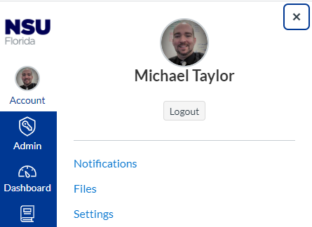

Switching Between Two Cameras During a Meeting
If you have more than one web camera connected to your computer, you can actively switch back and forth between cameras during a Zoom session.
- Click the up arrow to the right of the Start/Stop Video button on your Zoom control panel.
- Click the name of a camera on screen to actively switch
or
Use the keyboard combination of Alt + N to switch on the fly.
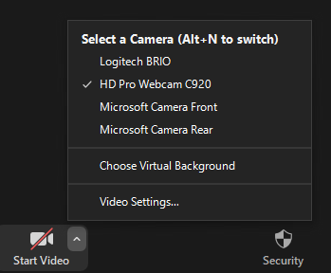

Publishing Your Zoom Recording to Canvas
After your recording has been completed a copy of it will be available in SharkMedia later that day. From the Media Gallery in your Canvas course, you can make your Zoom recording available to your students.
- Access your Canvas course and select Media Gallery.
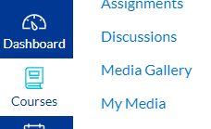

- Locate the Add Media button in the upper right corner of your course media gallery.
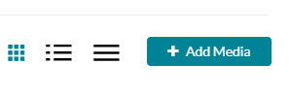

- Click the checkbox next to the recording you want to add to your course media gallery and click Publish in the top right corner.
