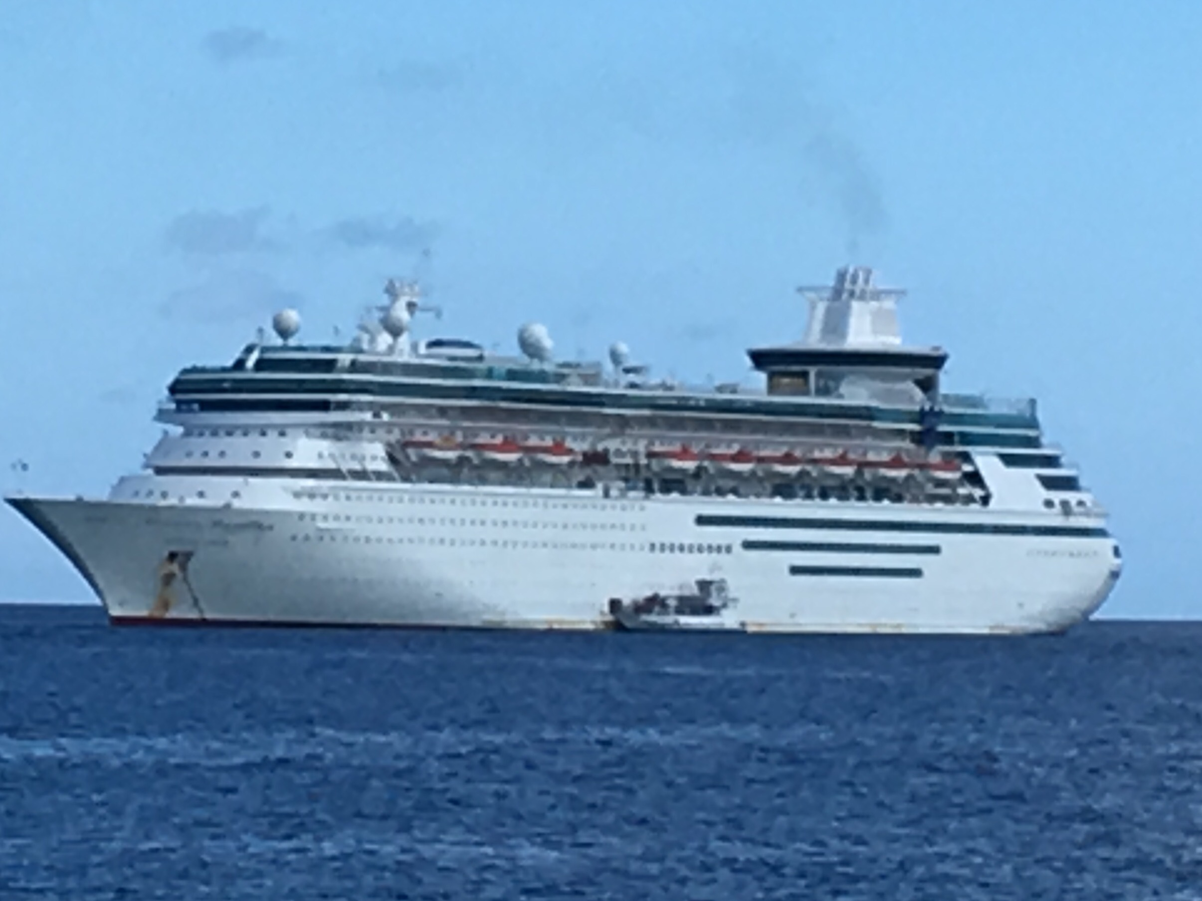  June 19-25, 2018  Study Abroad on royal caribbean enchantment of the seas  CRJU 4900, Special Topics in Maritime/Private Security Studies  The course will provide students with an opportunity to learn about maritime security with Port Canaveral and Royal Caribbean, Inc. Students will spend two days at Port Canaveral learning about port security and management, and public/private law enforcement collaborations. Students will travel aboard the Enchantment of the Seas for three days to Nassau, Bahamas and Coco Cay. Students will learn about risks, challenges, and innovations to cruise ships and the maritime environment. The course will explore a global and cultural perspective of security and maritime studies. | Register for Summer 2018  ────  Course counts as an elective toward graduation  ────  Deposit due March 15  ($875.00)  ────  Final Payment due April 5  ($875.00)  ────  Course is 3-weeks long (online) with 1 week of travel  For more information:  Dr. Jennifer M. Allen  Professor  Department of Justice and Human Services  954-262-7878  jallen@nova.edu
*A minimum of 16 registered students is required to fulfill the course. Cost is subject to change depending on the number of students enrolled.

