College of Arts, Humanities, and Social Sciences

Department of Justice and Human Services
Visit Port Canaveral, Florida, Nassau, Bahamas, and Coco Kay, Bahamas
Meet public and private law enforcement and security officers at the local, state, and federal levels
Sail aboard the Enchantment of the Seas, Royal Caribbean, Inc.
Earn a certificate in Security Awareness Training for Seafarers
Learn from the Fleet & Port Security Manager
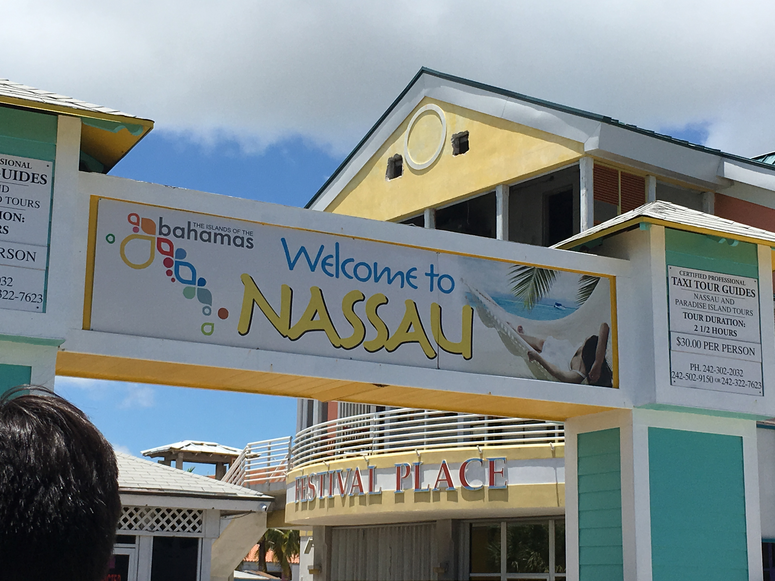
All documents and payments to be submitted to Office of International Affairs at http://www.nova.edu/internationalaffairs/travel-study-abroad/travel-study/index.html.
All payments are non-refundable unless the class is cancelled

CRJU 4900, Special topics in maritime and private security studies
Topics in criminal justice that are not included in regular course offerings. Specific content is announced in the course schedule for a given term. Students may re-enroll for special topics covering different content.
This course is open to ALL majors and degree levels. Prerequisite is waived. A driver’s license is required. A passport is strongly recommended for travel out of the U.S.

Course information and Travel itinerary:
June 11-18, 2018 – Online Material and Lecture
June 19, 2018 – Travel from Fort Lauderdale, FL to Port Canaveral, FL
June 20-21, 2018 – Attend on-ground presentations at Port Canaveral, FL
June 22-25, 2018 – Sail aboard the Enchantment of the Seas to Nassau, Bahamas and Coco Kay, Bahamas – Attend presentations onboard the ship
June 25, 2018 – Return to Fort Lauderdale, FL
June 26-29, 2018 – Online Material and Lecture
June 29, 2018 – Last day of course

Cost
Not Included in the Study Abroad Fee:
- Tuition and NSU Fees for the course
- Meals and snacks in Port Canaveral, FL
- Incidentals including excursions, onboard drink packages, gambling costs, etc.
- International phone or internet
Included in the Study Abroad Fee:

- Travel to/from Ft. Lauderdale and Port Canaveral
- Price of Cruise
- Hotel in Cocoa Beach/Port Canaveral
- Food and Gratuities onboard the Enchantment of the Seas
- Parking at Port Canaveral
- Student Travel Insurance

