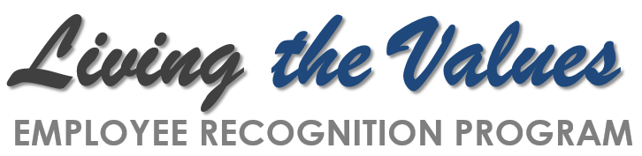
NOMINATION FORM
This Month’s Core Value is: (please circle appropriate Core Value)

Academic Excellence | Integrity | Opportunity | Diversity
Student Centered | Innovation | Scholarship/Research | Community

The purpose of the Living the Values program is to recognize co-workers who are living NSU’s eight core values. Please give completed nomination forms to your area’s Human Resources Contact. Throughout the month, employees can be nominated any number of times, so ‘catch’ your colleagues Living the Values!
Person Being Nominated: ___________________________________ Date:________________
Department:_________________________________ Title:_____________________________
Please provide a brief explanation of how your nominee is Living the Core Value:
- Situation (Please describe when and where the behavior took place.) ________________________________________________________________________
________________________________________________________________________
________________________________________________________________________
- Behavior (Please describe in detail exactly what the nominee did to demonstrate the Core Value of the month.)
________________________________________________________________________
________________________________________________________________________
________________________________________________________________________

- Impact (Please describe how the nominee’s behavior enhanced the experience of being a part of Nova Southeastern University.)
________________________________________________________________________
________________________________________________________________________
________________________________________________________________________

Nomination Completed By: _______________________________________________________
HR Contact: ____________________________________________________________________

