One of the things that can help you clarify your thoughts about your decision is to list all the benefits and costs of changing. This exercise is intended to help you think about what is involved in your decision to change. Remember that it is your decision to change! You are the one who must decide what it will take to tip the scale in favor of change.
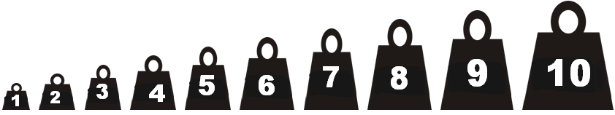

Once you list the good and less good things about changing, assign a weight value for each one. Think about how important each one is to you right now. Then, add up your weights for each column and enter them in the scale below to see where you stand today on your decision to change.
GOOD THINGS
_________________________________________________________________________________________________________________________________________________
LESS GOOD THINGS
_____________________________________________________________________________________________________________________________________________________________________________________________________________

