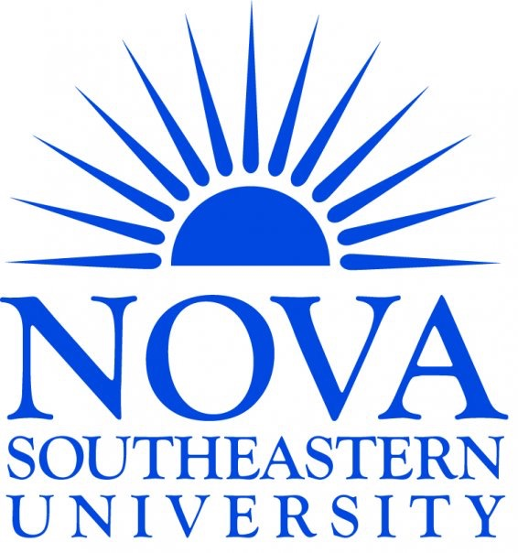  Environmental Health & Safety SOP PERSONAL PROTECTIVE EQUIPMENT | VERSION # 1.0 | Page  1 of 3

Purpose
To ensure all staff understand the correct PPE to be worn when utilizing the Gross Anatomy laboratories.

Scope
This SOP is to be used by anyone with authorized to work in the Gross Anatomy laboratory.

Table of Contents
AUTHORITY AND RESPONSIBILITY 3
TARGET USERS 3
DEFINITIONS 3
REFERENCED SOPS 3
MATERIALS (consumables, equipment, etc) 3
Personal Protective Equipment donning and doffing for the Gross Anatomy Lab 3
1. Entering into the Lab 3
2. Exiting from the Lab and removing PPE 3

AUTHORITY AND RESPONSIBILITY
It is the responsibility of each researcher using the Gross Anatomy Lab to follow the entry and exit procedures. It is the responsibility of the Lab Manager to ensure proper procedures are followed.

TARGET USERS
- EHS Staff
- Lab manager
- Lab staff and authorized users
- Security Staff
- Facilities Management Staff

DEFINITIONS
None

REFERENCED SOPS
- SOP for Gross Anatomy Lab Access

MATERIALS (consumables, equipment, etc)
Personal Protective Equipment (PPE) Disposable:
- Disposable Isolation Gown
- Nitrile Gloves
- Shoe Covers (optional)

Personal Protective Equipment (PPE) Non-Disposable:
- Scrubs
- Closed-toe shoes
- Safety glasses/goggles

Personal Protective Equipment donning and doffing for the Gross Anatomy Lab
Individuals not following the correct PPE requirements outlined in this SOP will not be permited to enter the lab.

Entering into the Lab
  - Before entering the lab, put on the following PPE in this order:
    - Safety glasses or goggles if work has potential for splash (appropriate for active dissection activities)
    - Disposable gown (students) and/or gowns/lab coats (for staff/faculty)
    - Nitrile gloves
    - Shoe Covers (optional)

Exiting from the Lab and removing PPE
  - To exit the gross anatomy laboratory, remove your outer PPE in the follwing order while still in the main lab:
    - Remove disposable gown and discard in trash
    - Remove shoe covers if worn
    - Remove nitrile gloves and discard in trash
    - Remove goggles or safety glasses and clean
    - Any PPE that has been contaminated with chemicals it should be handled as hazardous waste.
  - Wash hands with soap and water in the handwash sink before exiting the lab.

NOTE: No soiled personal protective equipment shall leave the lab.

