Add dell pages in trusted sites:

- Open IE Browser
- Click Tools Menu
- Click on “Internet Options” option
- “Internet Options” model window is displayed

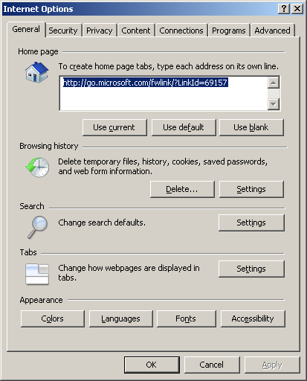

- Select “Security” Tab

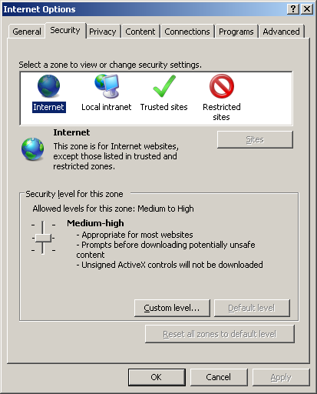

- Select “Trusted Sites” Icon
- Click on Sites button

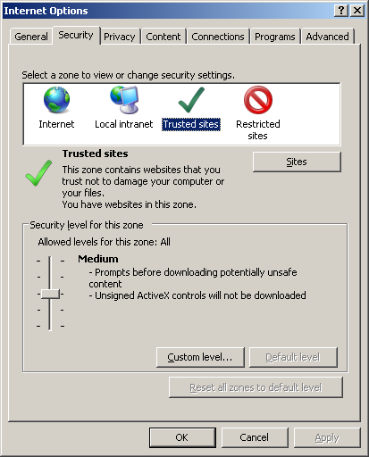

- “Trusted Sites” child window comes up
- Type “*.dell.com” in Add this website to the zone text box
- Un-Check require server verification checkbox
- Click on Add button

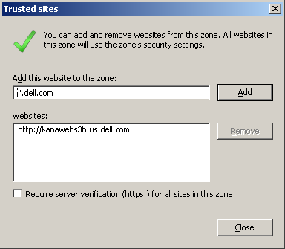

- “*.dell.com” gets added to the Websites list box
- Please Note: “Require server verification (https) for all sites in this zone” should be unchecked before you add *.dell.com to your trusted sites. *.dell.com should be NOT be prefixed with https://
- Click on Close button to save the settings and close child window

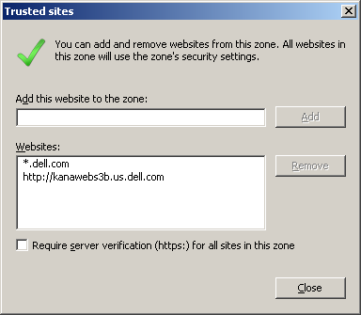

- Click OK button to close model window
- Close and open the IE again

