How will I receive the link to begin participating in the
“ME/CFS Genes Study”?
For privacy reasons, all email communication between the study coordinators and participants, will be through encrypted emails.
You will receive an email with the subject line “ME/CFS Genes”. The body of the email states you have been sent an encrypted email message and is shown below. The message will contain a link to access the encrypted message.
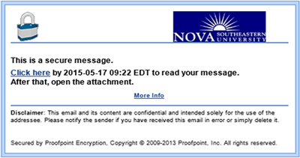
In order to view the contents of the email, you will have to click on the link above and you will be redirected to a new window where you will create an account. Please keep this account information handy as it will be required when opening any future correspondences from us.
**Please note, you will only have to create an account once**
**Any correspondence regarding this study WILL be encrypted**

