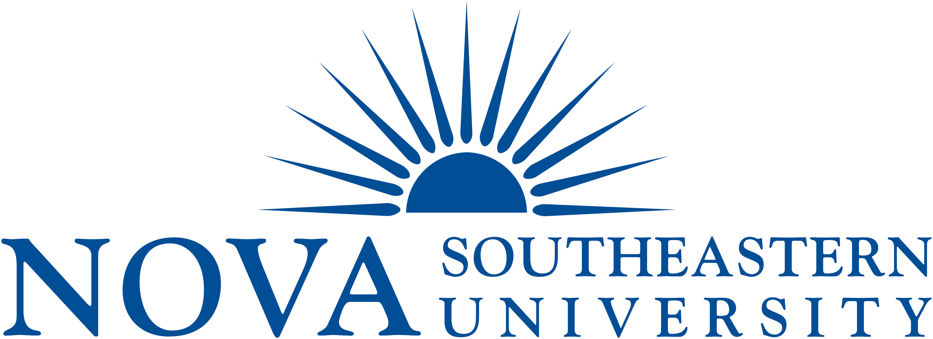

SAMPLE
DOES NOT INCLUDE LATEST UPDATES

Meet the Staff!

Benefits
Darline Blanc | Benefits Specialist: Handles insurance billing reconciliations and audits
Vacant | Benefits Specialist: Handles insurance billing reconciliations and audits
Diane Emery | Director, Total Rewards: Oversees employee benefits administration including retirement
Nancy Papernick | Benefits Manager: Medical, dental, workers’ compensation, and retirement program

Compensation
Kim Greenfest | Director, Compensation: Oversees compensation programs/issues
Ileana Kyriakides | Compensation Analyst: Performs job analysis & job audits, compensation analysis, conducts/completes surveys
Cherelle Dawes | Compensation Analyst: Performs job analysis & job audits, compensation analysis, conducts/completes surveys
Kimberly Schaefer | Compensation Specialist: Assists in general compensation issues/projects

Employee Relations
Maria Pinto | Employee Relations Director: Oversees Employee Relations, Grievances, develops and maintains comprehensive employee relations program
Aura Aleman | Senior Employee Relations Specialist: Assists in the employee relations activity; serves as contact for departments for potential employee relations issues, grievances, investigations, and workplace issues, etc.
Arnetta Pierce | Senior Employee Relations Specialist: Assists in the employee relations activity; serves as contact for departments for potential employee relations issues, grievances, investigations, and workplace issues, etc.

Employment Processing/ HRIS
Kathy Shaffer | HRIS Analyst: Process new hire, rehire and internal transfer, status changes paperwork
Sharifa Coombs | HRIS Assistant: Process new hire, rehire and internal transfer, status changes paperwork
Amy Goldstein | HRIS Director: Computer system maintenance and reports
Maria Nachmann | HRIS Analyst: Process new hire, rehire and internal transfer, status changes paperwork

Operations
Jennifer Barrett | Executive Assistant to Associate Vice President: Administrative support; responsible for overseeing daily operational duties/maintenance of OHR facilities; maintains OHR web page
Mark A. Jones | Associate Vice President of Human Resources: Oversight of OHR functions/activities and University personnel budget issues
Patricia Shim | HR Assistant: Administrative support to OHR activities

Training
Maureen Simunek-Appelt | Manager of Training and Development: Develops and presents training programs, workshops, new employee orientation, coordinates United Way drive

